Howard County Open Goat Show
Tuesday, June 23, 2026
6:00 PM

Money to top head in each division…
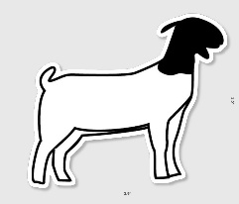
Top Market…$50, $25, and $10
Top Nanny…$50, $25, and $10
Top Billy…$25 and $10

*Kiddy class shows first, Nannies, Billys, Market, and Showmanship
*Check-in/Weigh-in 4:00-5:00 pm
*Market show by weight
*Entry form found on fair website…hocomofair.com

$10 per head
$5 gate fee per person…exhibitor gets in free, if call/text ahead of time
Exhibitor | Nanny, Billy, Market | DOB

One entry sheet per exhibitor
You can also text info. to Paden

For more information contact
Paden Boulden…660-728-3663

