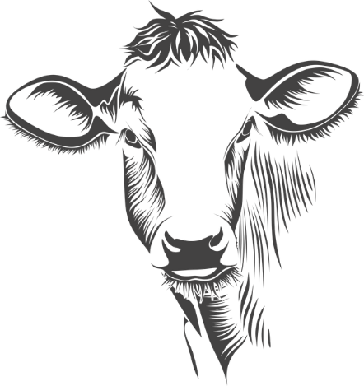
Howard County Open cattle show

Thursday, June 23, 2022
7:00 pm

Money to top 5 head in each division…
Market Steers & Heifers
$200 - $100 - $75 - $50 - $25
Sponsors:
Howard County Cattlemen – Champion Steer & Heifer Triple Z Farms – Showmanship
Chad & Bridget Fuemmeler – Res. Heifer Bar Tumbling K – Res. Steer
Double Bar K Wies Limousin

$20 per head pre-entry by June 20……$25 after June 20

*Check-in/Weigh-in between 4:30-5:30 pm *Registration papers for breeding stock classes
*Steers show by weight *5 head/2 exhibitors to classify a breed
*Bucket calves show first, steers, breeding stock, and showmanship
$5 gate fee…if pre-registered by June 20 each exhibitor and 1 “Buddy” get in free.

Exhibitor | Breed | H/S/Bucket/Bull/Pair | DOB

One entry sheet per exhibitor
You can also text me the info.
Checks payable to FDA and mail to:
Sherri Dobson, 262 State Rt A., Fayette, 65248
660-728-3661 or sdobson62566@gmail.com for questions

