Open 4D Barrel Race
Howard County Fairgrounds, Fayette, MO
Wednesday, June 22, 2022
In conjunction with the Howard County Fair
Books Open @ 5:30 pm
$500
Added Money
$500
Added mney
Arena closes @ 6:00 pm
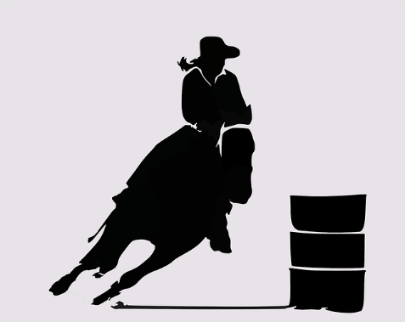
Exhibitions 6:30-7:30 pm
Pee Wee – 8:00 pm
Open to follow Pee Wee
***half, half, whole split***
Entry Fees:
$5 per exhibition
$5 gate fee per person $30 per horse (75% payback)
(exhibitor FREE) $10 Pee Wee (100% payback)
CASH PLEASE
Payout will be CASH!

For more information contact Sherri Dobson (660) 728-3661

Sponsors…

CALLAWAY LIVESTOCK CENTER McBee
This Photo by Unknown Author is licensed under CC BY-NC-ND
Offers the weekly top market for your cows,
calves, and finished cattle
For on farm appraisals and trucking see..
Jack Harrison
(573) 999-7197 Cattle
Company

